**CSE523** Machine Learning

Project: Shipment Price Prediction

Weekly Project Report: March 4, 2023

Team: **Revolution**

| Team Members | Enrolment-ID |
| --- | --- |
| Deep Patel | AU2040250 |
| Roshni Navdiya | AU2040114 |
| Aditya Padhariya | AU2040151 |
| Keval Parmar | AU1940133 |



* **Task Performed this week:**

1. Visualised and correlated the selected SCMS dataset using scatter plot and by checking outliers by boxplot.
2. Compared chosen parameters with each other using histogram and sns.barplot. To get the clear idea of dependency of parameters on each other.

* **Outcomes of the tasks performed:**

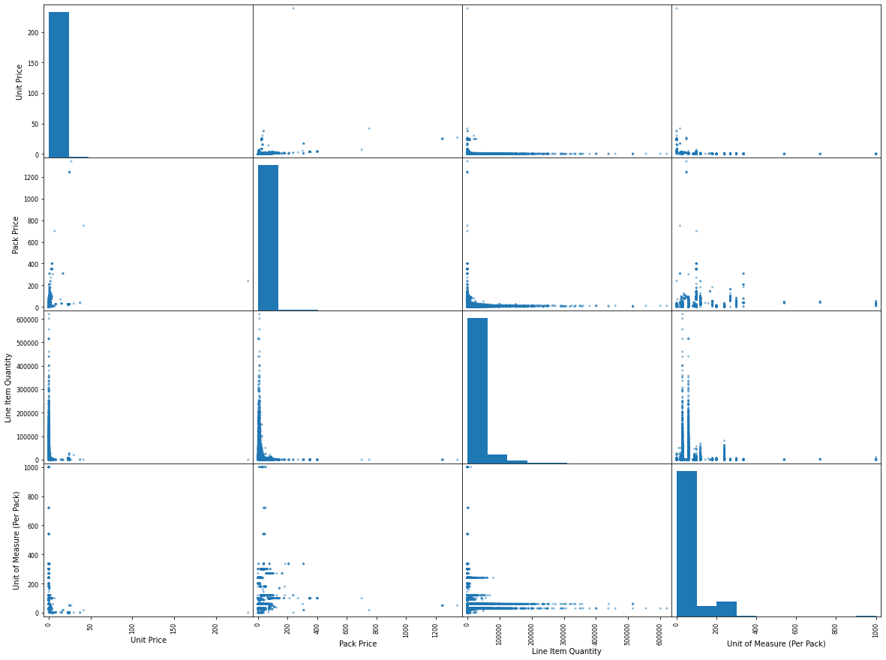

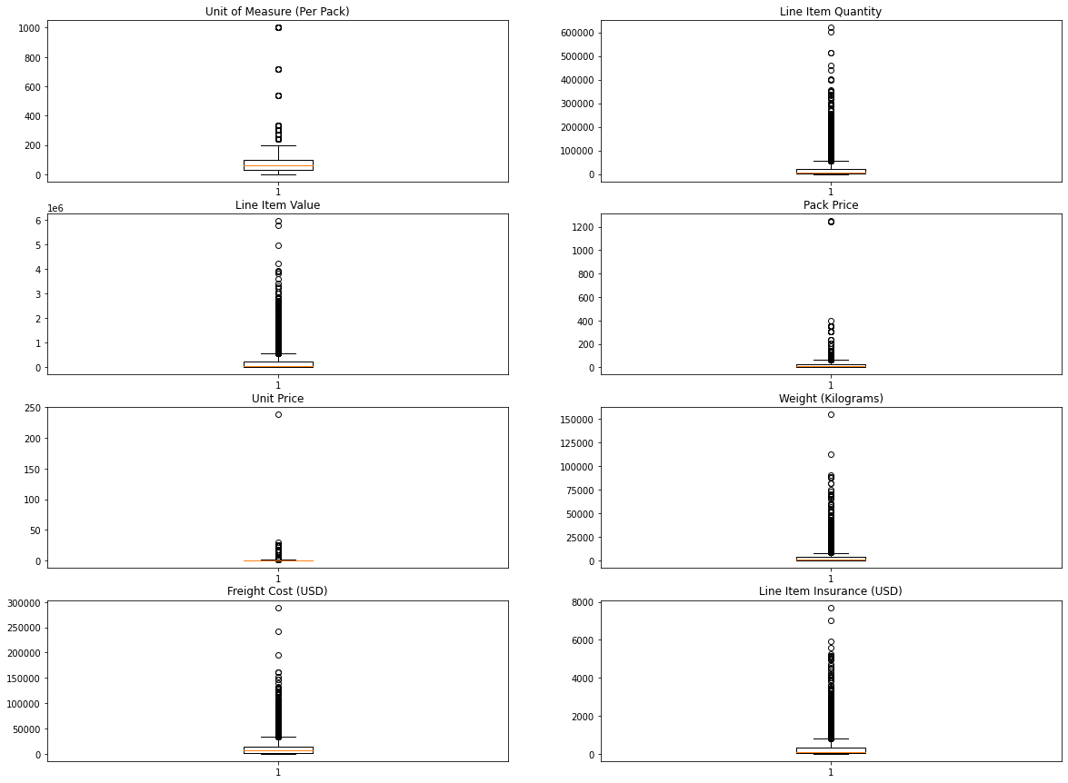

* **Tasks to be performed in the upcoming week:**

1. To remove un-necessary data.
2. To perform data splitting for training and checking on different models.
3. Initiating the model fitting methods.